Fuzzy Logic Controller Requirements Document
System: Carriage Stabilization on Rotating Wheel
Platform: Raspberry Pi 4 (ARM Cortex-A72 @ 1.5 GHz)
Language: Python 3 with optional Embedded C modules

Purpose & Scope
This document defines the requirements for the design and implementation of a Sugeno-type Fuzzy Logic Controller (FLC) responsible for maintaining a carriage at the topmost position on a rotating wheel. The carriage travels along the outer perimeter of a wheel that is free to rotate about its central axis but fixed in space.
A 3-axis gyro and accelerometer is mounted on the carriage, with its local X and Y axes constrained to align with the radial and tangential directions of the wheel, respectively—that is, the X-axis always points radially inward toward the wheel’s center, while the Y-axis remains tangent to the path of motion. The gyroscope Z-axis measures angular velocity (ω) about the wheel’s axis. A positive value of ω indicates clockwise rotation of the carriage relative to the wheel's fixed frame.
The FLC processes motion and position data from the sensor to compute motor commands that drive the carriage circumferentially, actively counteracting the wheel's rotation to maintain the carriage’s position at the top.

Definitions
- Wheel: A 48-inch diameter circular frame, free to rotate in either direction.
- Carriage: A movable unit traveling along the wheel's outer diameter.
- Motor: Force provider to move the carriage around the wheel.
- theta: The angular position of the carriage relative to the highest point of the wheel.
- omega: absolute angular velocity of carriage irrespective of the angular velocity of the wheel.
- FLC: Fuzzy Logic Controller.
- Sugeno-Type System: A fuzzy inference system with output values defined as functions of input variables.
- Normalized Output/Input: Input or output values scaled to [-1.0, +1.0].
- CW / CCW: Clockwise / Counter-clockwise.
- Control Rate: The period of outermost software loop of the controller.

Real-Time Execution
- The FLC shall run at a minimum control rate of 50 Hz (20 ms cycle time).
- All input values shall be updated within each control cycle.
- Output motor command must be available with deterministic latency (<10 ms) after receiving input values.

Block Diagram
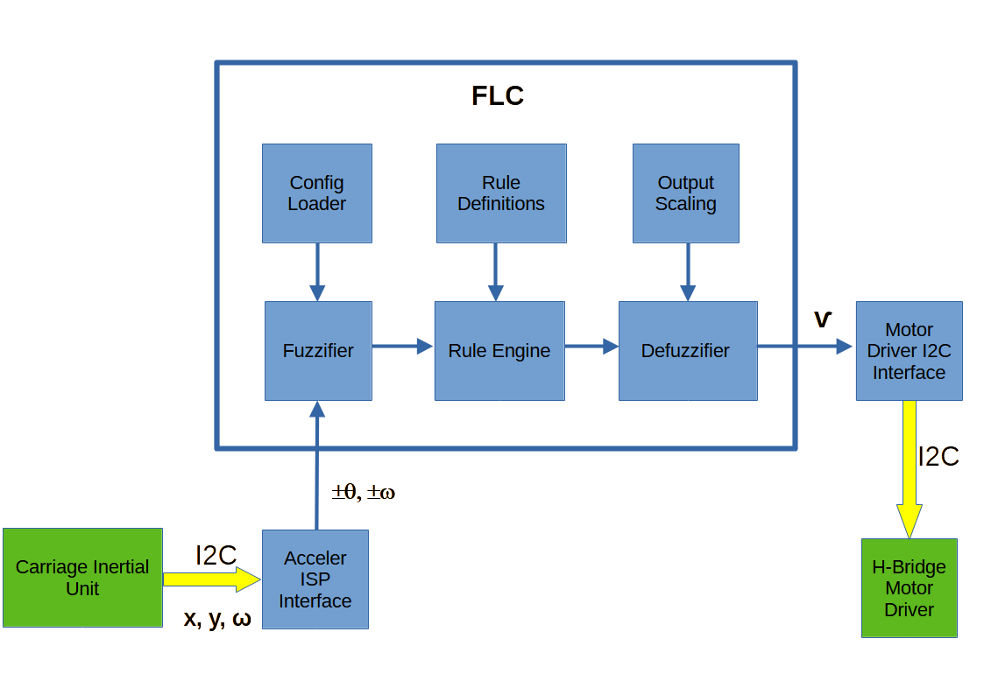

Inputs
The FLC system shall accept the following two normalized floating-point inputs:
- θ: The angular position in radians of the carriage around the wheel: Range -π to +π : θ = 0 when the carriage is at the top of the wheel.
- where X & Y are components of a rotating vector of fixed magnitude G.
- ω: The angular velocity of the carriage: Range -π/s to +π/s

Inputs are calculated and provided by a software Gyro/Accelerometer Driver Module (imu_driver.py) that reads periodic X / Y and ω outputs from the gryo/accelerometer over an SPI bus at the FLC control rate.
θ = atan2(y, x)
Python code should use ATAN2 library function to calculate θ.
ω = gyro z axis output

Output
The FLC shall produce a normalized floating-point value for the motor speed and direction needed to move and maintain the carriage at the top of the wheel, θ = 0
- motor_cmd: Normalized motor speed command (-1.0 to +1.0)
- motor_cmds less than 0 cause the hardware motor driver to rotate the motor CCW
- motor_cmds greater than 0 cause the hardware motor driver to rotate the motor CW
- motor_cmds equal to 0 cause the hardware motor driver to free the motor.

PWM signals to the Motor Hardware
The motor_cmd produced by the defuzzifier will need to be rescaled before use by the imu_driver. The motor hardware has two inputs pwm0 and pwm1 that control both the direction of rotation and the speed of rotation. The speed is set by varying the duty cycle of a PWM signal between 0 and 100%. If pwm0 is driven with a PWM pulse train and pwm1 is set to level 0 the motor spins CW. Reversing the signals applied to pwm0 & pwm1 causes the motor to spin CCW. Applying a level 0 to both pwm0 & pwm1 stops the motor rotation.

System Constants
All constants and parameter values shall be defined in flc_config.json
- Given physical parameters:
WHEEL_TO_MOTOR_RPM_RATIO
MAX_MOTOR_RPM
MAX_WHEEL_RPM

Fuzzy Controller Design

Type
Sugeno-type fuzzy inference system.

Membership Functions
The universe of discourse of each of the fuzzy variables is represented by a set of membership functions. There shall be seven (7) fuzzy sets for position error. Position error is the angular deviation from vertical-up; i.e. the carriage centered at the top of the wheel. The expectation is that 7 fuzzy sets provide significant resolution for the position of the carriage.
There shall be five (5) fuzzy sets for velocity error. Velocity error is the deviation from ω = 0.
All fuzzy sets shall be represented by membership functions with triangular shapes with 50% overlap.

Abbreviation:
LE – Large Error
ME – Medium Error
SE – Small Error
NE – No Error
LV- Large Velocity Error
SV- Small Velocity Error
NV- No Velocity Error

CC – Clockwise
CCW – Counter-clockwise

The position input shall use 7 fuzzy member functions:
- LECW
- MECW
- SECW
- NE
- SECCW
- MECCW
- LECCW

The velocity input shall use 5 fuzzy member functions:
- LVCW
- SVCW
- NV
- SVCCW
- LVCCW

Rule Base
A rule base may contain up to 7x5 = 35 rules (prepared in matrix format).
Rules may be optimized or pruned based on relevance and symmetry.
The motor_cmd output shall use Sugeno type rules.
Example:
IF θ is NE AND ω is SVCW THEN
motor_cmd_{i} = 5.0 * θ + 10.5 * ω + 5

(Coefficients shown are for example only)
Sample rule definition in JSON from flc_config.json :
{
"rule": ["NE", "SVCW"],
"output": {
"theta_coeff": 5.0,
"omega_coeff": 10.5,
"bias": 5.0
}
}

The final output of the FIS will be a weighted average of the outputs of all active rules:

where:
W = firing strength of rule i,
Z = output from the ith rules crisp function.
N = the number of rules

Output
Defuzzification yields a scalar value for motor control. The module motor_driver.py shall convert motor_cmd to a 13 bit signed integer motor command transferred to an H_Bridge hardware motor driver circuit via an SPI interface.
The PWM signal shall be generated by the module motor_driver.py. The motor driver shall update the PWM duty cycle at each control loop iteration (50 Hz), while generating the PWM signal continuously at a frequency of 50Hz or less.

Program Structure
- main.py
- flc/
- controller.py # FLC logic
- fuzzifier.py # Input membership functions
- rule_engine.py # Sugeno rule base
- defuzzifier.py # Output computation
- sensor/
- accel_driver.py # Accelerometer interface & derived values
- platform/
- motor_driver.py # PWM or motor output command interface
- config/
- flc_config.json # Tunable parameters & rule matrix
- utils/
- logger.py
- profiler.py
- test/
- test_accel.py
- test_motor.py
- test_controller.py
- test_rule_engine.py
- test_fuzzifier.py
- test_defuzzifier.py

- main.py: The entry point. Coordination of initialization, looping, and system integration is implied.
- flc/ submodules:
- controller.py: Central FLC logic that integrates fuzzifier, rule engine, and defuzzifier.
- fuzzifier.py: 7 membership functions for θ and 5 membership functions for ω, fully specified.
- rule_engine.py: Sugeno-style rule base with up to 35 rules logic implied.
- defuzzifier.py: Outputs scalar value from Sugeno outputs. Clear and bounded.
- sensor/accel_driver.py: Described as generating normalized inputs from raw accelerometer data (cos_theta, sin_theta, dX/dt, dY/dt).
- platform/motor_driver.py: Responsible for translating motor_cmd into GPIO PWM output.
- config/flc_config.json: External definition of membership parameters and rule base.
- utils/logger.py and profiler.py: Support modules for data logging and performance timing.

Optional performance-critical paths (e.g., fuzzifier) may be implemented in embedded C and wrapped with Python via ctypes or cffi.

Interfaces

Sensor Interface
SPI bus interface from the accelerometer IC to the accelerometer driver module updated via internal polling at software control rate.
Simple IIR shall be used to smooth accelerometer data, where FC = 5Hz and FS = 50Hz.

Motor Interface
Signed 16 bit integer is passed to motor driver hardware via SPI serial interface.

Config Interface
JSON file to define:
Membership function parameters
Rule base
Output mapping
System Constants
System Parameters

Coefficient Identification
- Membership function bounds and rule Consequents shall be tuned:
- Initially via simulation
- Refined through empirical adjustment during physical tests
- Tunable values shall be defined in flc_config.json
- Auto-tuning tools or scripts may be provided.

Target Performance Criteria
- Carriage overshoot? ±5°
- Settling time< 2 seconds
- Controller latency< 10 ms
- Mean absolute error 3°
- CPU usage (1 core) < 40%

Verification & Validation
- Unit Testing: All New Modules
- Simulation Testing: Using synthetic accelerometer data
- Hardware-in-the-Loop (HIL): Final validation on real system
- Logging: Real-time data logging for test analysis

Deliverables
- Python3 source code with documentation
- JSON config files (membership and rule base)
- Unit test scripts
- Performance evaluation logs
- (Optional) Jupyter notebooks for tuning/simulation
- README with installation and usage instructions

Non-Functional Requirements
- Platform: Raspberry Pi 4, 64-bit Raspberry Pi OS (latest stable)
- Language: Python 3.9+, with optional embedded C modules

- Required Libraries:
- numpy
- scipy
- matplotlib (for tuning/plotting)
- cffi or ctypes (C interface)
- pytest (testing)
- busio (SPI, SPI serial interface)
- Maintainability: Modular code with function-level docstrings
- Reliability: Graceful fallback for sensor failure or out-of-bounds data
- Portability: Code should be portable to other ARM Small Board Computers

